polybase sql to sql
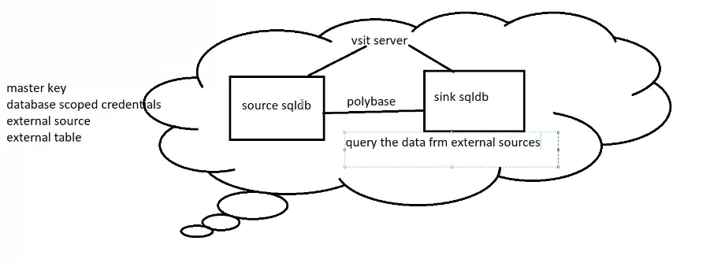
Create sql database source side and sink side with same sql server
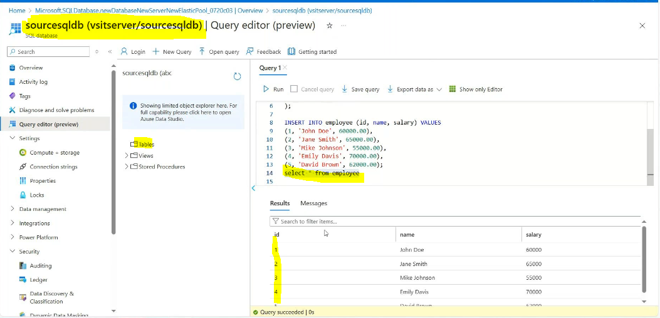
Sink sql databse:
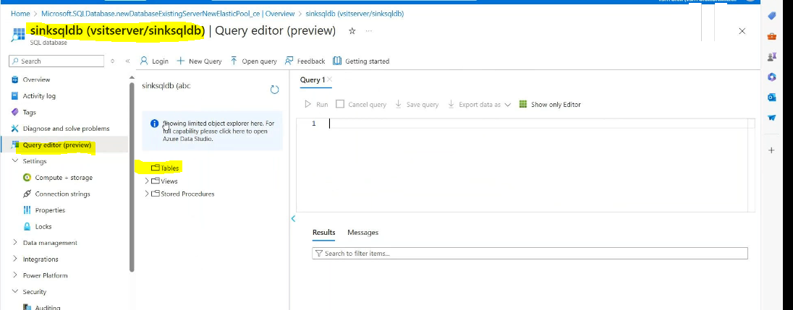
Sink sql database connected with ssms(by using server name we creating 2 sql db’s that’s way it would be conectesd source side sql db and sink side sql db)
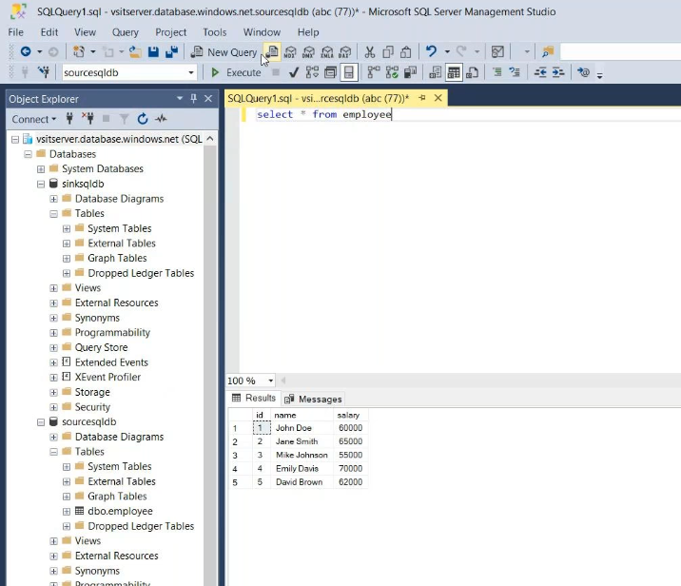
What is Poly base:
In source data base we have tables and we execute the table’s and result come, in sink table we don’t want to copy the same data but we want that execute results at that time poly base come in to the picture
For that we need 5 steps:
1 master key
2 database scoped credentials
3 external data source
4 external file format
5 external tables

This steps will do in sink databse
Step-1
create master key encryption by password='vs@anu@123' --- Creating a New Password
Step-2
create database scoped credential ploybase ---Creating a New Database
with
identity='avinash' -----You can give a any name | -----You can give a any name
secret='bbTFkPuFhHNjpKx/qUuLJWi2yB+kRQvzyE4gQbcbrEFShx2Uaz7Aslav9tPPt53guMAOcAU3e9XA+AStv2V5JA==' --------it is of secrete of blob storage available in the ACCESS KEY
Step-3
create external data source ploy_source ---creating a external data source
with
(
type=hadoop
location='wasbs://input@blobdwh123venu123anu.blob.core.windows.net' -----(in this eclasess456 is a Container name and eclasess123 is a Blob storage name) | -----(in this eclasess456 is a Container name and eclasess123 is a Blob storage name)
credential=ploybase --------Step2
)
Step-4
create external file format file1 -- creating a external format
with(
format_type=delimitedtext
format_options(field_terminator=' ' first_row=2)) | ' | first_row=2))
Step-5
create external table product1
(
eno int
ename varchar(10)
esal varchar(10))
with(
data_source=ploy_source ---Step3 | ---Step3
file_format=file1 #NAME? | #NAME?
location='/2023/')-----Foldername
select * from product1
Step-6
CREATE TABLE [dbo].[DimProduct]
WITH (DISTRIBUTION = HASH([eno] ) ) ------Distribution method above 2gb
AS SELECT * FROM [dbo].[product1] ;
CREATE TABLE [dbo].[DimProduct1]
WITH (DISTRIBUTION = Round_robin ) ------Distribution method below 2 gb
AS SELECT * FROM [dbo].[product1] ;
CREATE TABLE [dbo].[DimProduct2]
WITH (DISTRIBUTION = REPLICATE ) ------Distribution method less than 500 rows or 10 mb
AS SELECT * FROM [dbo].[product1] ;

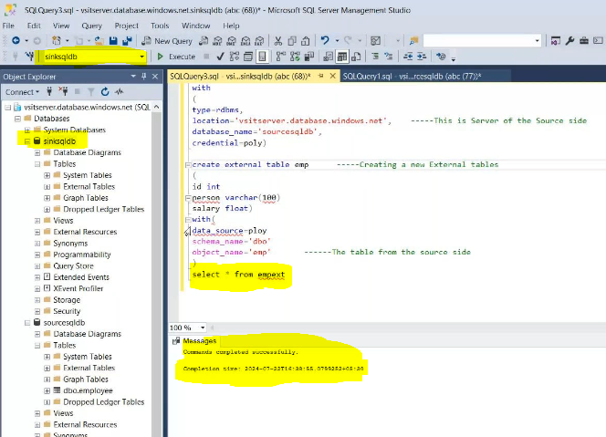

After that we need go to sinksql database
